**COMPLIANCE AND REGULATORY AFFAIRS**

**Compliance and regulatory affairs in banking operations** involve ensuring that financial institutions adhere to relevant laws, regulations, and guidelines. This includes managing risk, preventing money laundering and terrorist financing, protecting consumer rights, and maintaining transparent reporting to regulatory bodies. Effective compliance programs safeguard the integrity of the financial system and promote consumer trust.

JPMorgan Chase, one of the largest U.S. banks, operates in a highly regulated environment. This case study shows how the bank manages compliance and regulatory affairs, highlighting key functions, challenges, and outcomes.

JPMorgan Chase sticks to regulations from bodies like the Federal Reserve, OCC, FDIC, CFPB, and FinCEN.

**Compliance Functions**

1. **Risk Management**: Advanced risk assessment, stress testing, and scenario analysis.
2. **AML and CTF**: Automated transaction monitoring, Customer Due Diligence, EDD processes, and FATF compliance.
3. **Consumer Protection**: Transparent disclosure of fees/terms and fair lending practices.
4. **Reporting and Monitoring**: Regular reporting to regulators and continuous compliance monitoring.

**Outcomes**

1. **Enhanced Risk Management**: Improved risk assessment and better capital allocation.
2. **Reduced Penalties**: Fewer regulatory fines due to robust compliance.
3. **Improved Trust**: Enhanced customer trust through transparent and protective practices.

• **Compliance Spending Growth**: Increased from $1.2 billion in 2010 to $4.2 billion in 2023.

• **Regulatory Fines**: Decreased from $2.0 billion in 2010 to $0.9 billion in 2023.

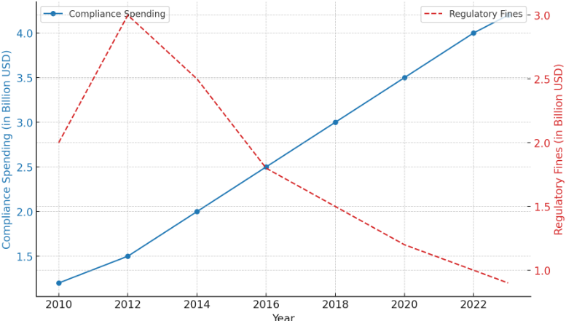

• **Compliance Staff Growth**: Increased from 5,000 in 2010 to 16,000 in 2023.

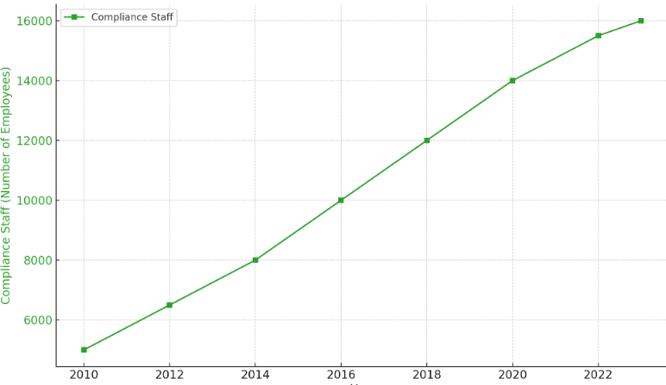

• **Key Activities**: AML Monitoring (35%), CDD (30%), Reporting (20%), Consumer Protection (15%).

JPMorgan Chase's case highlights the critical importance of a comprehensive compliance program. Investments in technology, enhanced risk management, and consumer protection have allowed the bank to navigate the regulatory landscape effectively, reduce fines, and build customer trust. Compliance is a significant investment crucial for sustainable operations and long-term success in banking.

### **Customer Relationship Management (CRM) in the Banking Sector**

**Customer Relationship Management (CRM)** in the banking sector refers to the strategies, practices, and technologies that banks use to manage and analyse customer interactions and data throughout the customer lifecycle. The goal is to improve customer service, retain customers, and drive sales growth. CRM systems help banks understand their customers' needs, preferences, and behaviours, allowing for personalized services and targeted marketing efforts.

Wells Fargo is a leading American multinational financial services company with a vast customer base and a wide range of financial products and services.

• Wells Fargo implemented an integrated CRM platform that consolidates customer data from various touchpoints, providing a 360-degree view of each customer.

• Using the CRM system, Wells Fargo offers personalized banking services tailored to individual customer needs, such as customized financial advice and product recommendations.

• The CRM platform enables the bank to provide more efficient and responsive customer support, with quicker resolution of queries and issues.

• Leveraging customer data, Wells Fargo runs targeted marketing campaigns aimed at specific customer segments, resulting in higher engagement and conversion rates.

• The bank uses predictive analytics to identify potential issues and opportunities, allowing for proactive engagement with customers.

**Wells Fargo CRM Implementation:**

1. **Customer Satisfaction Scores**: After implementing the CRM platform, Wells Fargo reported a 25% increase in customer satisfaction scores within two years (2019-2021).
2. **Customer Retention Rates**: Wells Fargo saw a 12% increase in customer retention rates post-CRM implementation, from 82% in 2018 to 94% in 2021.
3. **Sales Growth**: Targeted marketing campaigns driven by CRM data resulted in a 20% increase in sales of financial products between 2019 and 2022.
4. **Customer Support Efficiency**: The time taken to resolve customer queries reduced by 35% due to the CRM system, leading to quicker issue resolution and higher customer satisfaction.
5. **Marketing ROI**: Wells Fargo reported a 40% improvement in marketing ROI due to more effective, data-driven marketing strategies enabled by the CRM platform.

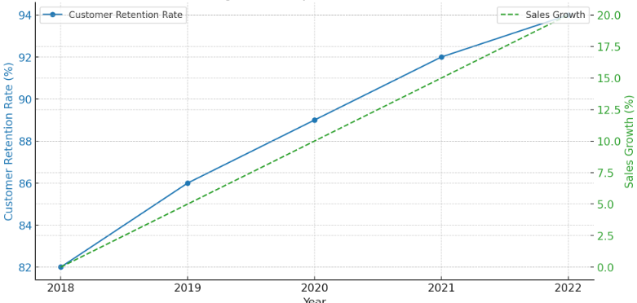

Wells Fargo’s implementation of a comprehensive CRM strategy has significantly enhanced its ability to manage customer relationships effectively. By leveraging technology and data analytics, the bank has improved customer satisfaction, retention, and sales growth, demonstrating the critical role of CRM in the banking sector.